|  |  |
| --- | --- |
|  | **STATEMENT OF WORK**  **IndyCar/IMS.com:** Crown Royal 400 at the Brickyard **|**  **11 June 2015** |

**Table of Contents**

1. Project Summary

Reference to Contract

Background

Livefyre Contacts

2. Project Deliverables

Deliverable Assumptions

Functional Requirements

Design

Delivery

Training

Support and Maintenance

3. Estimated Timelines

4. Technical Requirements

Minimum Browser and Device Requirements

Desktop Browsers

Mobile Browsers

5. Change Control

6. Resource Requirements and Cost

Project Cost Summary

Expenses

Term of SOW

Client Billing Contact

7. Ownership

8. Disclaimers

9. Authority to Proceed

Appendix A

Request for Change

# Project Summary

## Reference to Contract

Pursuant to the Master Services Agreement (“Agreement”) entered into by Livefyre, Inc. (“Livefyre”) and Indianapolis Motor Speedway (“Client” or “IndyCar/IMS.com” or “Customer”) dated with an effective date of December 10, 2014, Livefyre shall provide the Deliverables specified in this Statement of Work (“SOW”). This SOW shall have an effective date of June 12, 2015 (the “SOW Effective Date”).

## Background

IndyCar/IMS.com requested Livefyre to propose ideas for an experience that encourages fans to interact with IndyCar/IMS.com and its drivers, and be leveraged for sponsorships, increases brand awareness and can, ultimately, be re-used as a template for future events (for clarification in order for Customer to display any UGC content from Livefyre in this template Customer must posses a valid license from Livefyre). Livefyre will deliver “Brickyard 400” webpage (as described in Section 2 Deliverables) to meet these requests.

## Livefyre Contacts

|  |  |
| --- | --- |
| **Sales** | **Project Management** |
| **Chris Johnson**  Senior Enterprise Sales Lead  cjohnsonl@livefyre.com  630.408.1214 | **Pete Lim**  Project Manager  plim@livefyre.com  415.800.0892 |

# Project Deliverables (“Deliverables”)

Livefyre will design a webpage for “The Brickyard 400” that will meet the Functional Requirements in section 2.2. Designs referenced in the following functional requirements section are used as a reference to illustrate functionality and are not final.

## Deliverable Assumptions

## The following assumptions listed in section 2.1.1, highlight specific restrictions for the Deliverables with which Livefyre has based the scope of this project:

## General assumptions:

## Client responsible for defining content for Top Fan Submissions (See Section 2.2.5 – Top Fan Submissions) and Media Wall (See Section 2.2.5.3 – Media Wall), including configuration of collection used to populate Top Fan Submissions and Media Wall

## Client is responsible for identifying drivers to be used in Trending Drivers module (See Section 2.2.1.5 – Trending Drivers), along with configuration (Curate rules, moderation settings, etc.) of collections used to power Trending Drivers module

## Client responsible for providing Poll content (See Section 2.2.8 – Poll) for one (1) Poll to be used at launch.

## Client responsible for creating new Polls post-launch in Livefyre Studio and updating the Poll on the webpage.

## Design assumptions:

## Client must deliver to Livefyre all brand guidelines or sponsor brand guidelines and assets in advance of the design phase of the project (see Section 3 – Estimated Timelines)

## Maximum 1 round of design revisions as set forth in Section 5.

## Technical assumptions:

## No authentication/login integration

## Client is responsible for hosting and deploying the webpage templates to their environments

## Deliverables will work on mobile and tablet as a web view, however the deliverables will not include separate mobile optimized designs/implementations.

## Livefyre to provide Google Analytics tracking for time on page and page views via reports if requested in writing by Client and only during the Term of this SOW. If there are any additional analytics requirements, IndyCar/IMS.com must specify.

## Functional Requirements

1. Functional requirements describe in detail the elements of the “Brickyard 400” webpage listed in section 2.2.1

### Functional Requirements are included for the following sections:

### Header

### Step-by-Step

### Social Counter

### Top Fan Submissions

### Trending Drivers

### Fan Media Wall

### Poll Module

### Sponsored Ad

### Header

The header describes the webpage and provides links to other related properties.

### Header shall include the following elements (the “Header”): All elements in this section 2.2.2 must be provided by IndyCar/IMS.com.

### Title Graphic – Event logo. Graphic is static.

### Title Copy - Static text describing the event and displaying the hashtag to contribute to the MediaWalls.

### Video Embed - (Client must deliver YouTube URL) Will play single video inline using out of the box YouTube player.

### Sponsorship logo - Sponsor logo. Graphic is static.

### Any required outbound links - Hyperlinks to up to four URL’s of Client’s choosing. Links open in a new browser tab.

### The following graphic is a mockup of the Header (“Mockup 1”):

### Macintosh HD:Users:peterlim:Desktop:Screen Shot 2015-06-05 at 5.04.02 PM.png

### Step by Step

This module provides instruction on how to contribute social content to the webpage.

* + - 1. - Static copy describing how to submit content to the Media Walls on this page. Copy is broken out into 3 enumerated steps.
      2. - IndyCar/IMS.com must provide Livefyre with copy for this section.

### The following graphic is a mockup of the Step by Step (“Mockup 2”):

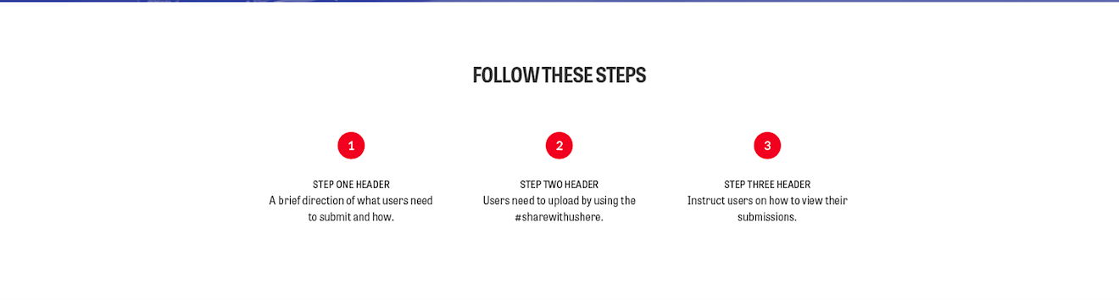

### Social Counter

Displays volume of social content for this campaign. Details in section 2.2.4.1- 2.2.4.3

* + - 1. A counter module which displays the aggregate number of pieces of content curated for the specified hashtag (hashtag to be provided by IndyCar/IMS.com)

### The social counter will be updated approximately every two minutes, as social UGC is processed by Livefyre.

### The following graphic is a mockup of the Social Counter (“Mockup 3”):



### Top Fan Submissions

A display of featured social content from fans.

### Livefyre will create one curated data collection for Tweets and Instagram posts containing a hashtag to be specified by Client.

### Livefyre will produce the Javascript embed code for one Media Wall that will display the data from the collection specified in section 2.2.5.1.

### The Media Wall will be styled to display three (3) pieces of featured content, which are selected by the client in the Livefyre Studio admin dashboard and will function as described on Livefyre Answers (<http://answers.livefyre.com/product/app-gallery/media-wall/>).

* + - 1. The Top Fan Submissions display will consist of the three most recent pieces of approved content in the featured content collection. Content and curation rules may by managed through the Livefyre Studio dashboard by Client.There will not be function to load more content outside of the three most recent pieces of content displayed.

### The Top Fan Submissions module will be updated in near-real-time, as social UGC is processed by Livefyre.

**2.2.5.6** The following graphic is a mockup of the Top Fan Submissions module (“Mockup 4”):

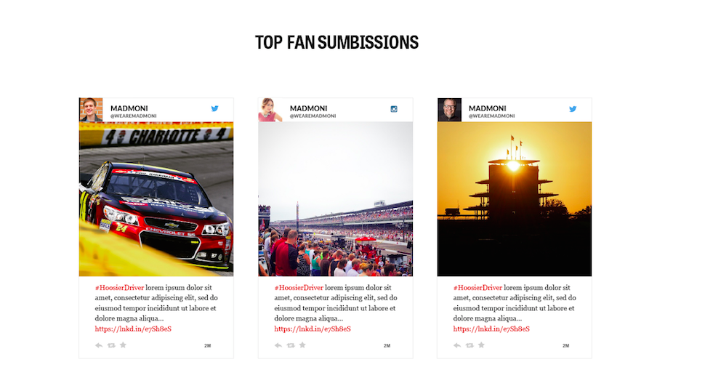

### Trending Drivers

Ranks some of the top trending drivers on social media.

### Displays static copy describing the module.

### Displays a vertical list of top drivers based on social activity

### Drivers will be stack ranked according to Livefyre’s heat index api, which is calculated by velocity over time of curated content to their collection. Collections and curate rules will be set up by Livefyre initially to curate content from the drivers’ Twitter and Instagram accounts.

### The Trending Drivers module will be styled within Livefyre Trending template specifications and will function as described on Livefyre Answers (http://answers.livefyre.com/product/app-gallery/trending/).

### The Trending Drivers module will be updated in near-real-time, as social UGC is processed by Livefyre.

### The following graphic is a mockup of the Trending Drivers module (“Mockup 5”):



### More Fan Tweets & Photos

Displays fan content from Twitter and Instagram

### Livefyre will create one curated data collection for Tweets and Instagram posts containing a hashtag to be specified by Client.

### Livefyre will produce the Javascript embed code for one Media Wall that will display the data from the collection specified in section 2.2.7.1.

### The Media Wall will be styled within Livefyre Media Wall template specifications and will function as describe on Livefyre Answers (<http://answers.livefyre.com/product/app-gallery/media-wall/>).

### The client can moderate content for the Media Wall in the Livefyre studio dashboard.

### The Fan Media Wall will be updated in near-real-time, as social UGC is processed by Livefyre.

### The Tweet button will open a new browser window via Twitter’s native API and will allow the user to submit a text only Tweet directly from the page.

* + - 1. The “View More” Button will load more content from the collection, pushing down other page modules below it.
      2. The following graphic is a mockup of the Fan Media Wall (“Mockup 6”):

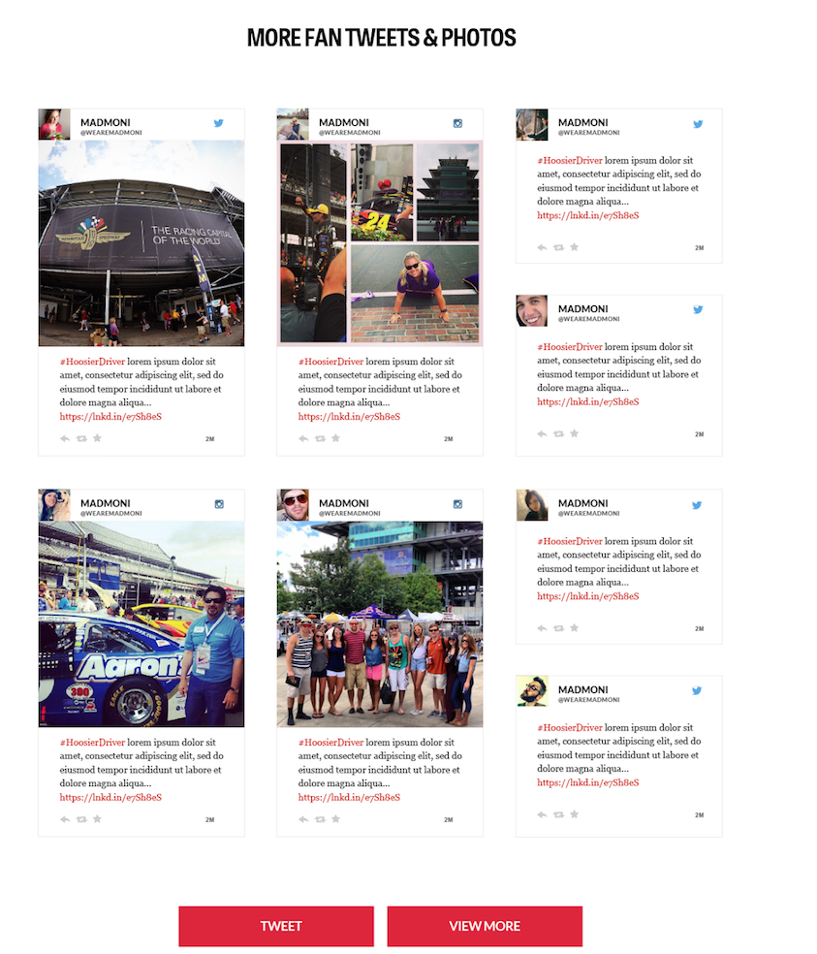

### Poll Module

This collects poll answers from site users.

### Livefyre will create one (1) poll within the Livefyre admin panel and provide Client with Poll ID. The packaged page template will display one (1) Poll Module. Client will have the ability to swap the poll on the page by changing the Poll ID in the code to another Poll ID. The Livefyre Polls functionality is described at <http://answers.livefyre.com/product/studio/polls/>

### Submitting an answer to a poll reveals poll results

### Editing poll questions and answers in Livefyre Studio does not reset poll results.

### Client will provide the question and answer copy for the Poll to Livefyre (see Section 3 – Estimated Timelines). Client will be responsible for refreshing subsequent polls on the page as described in section 2.2.8.1. Client will have the ability to create additional polls as needed through the Livefyre admin panel (as described at answers.livefyre.com).

### The following graphic is a mockup of the Poll module (“Mockup 7”):

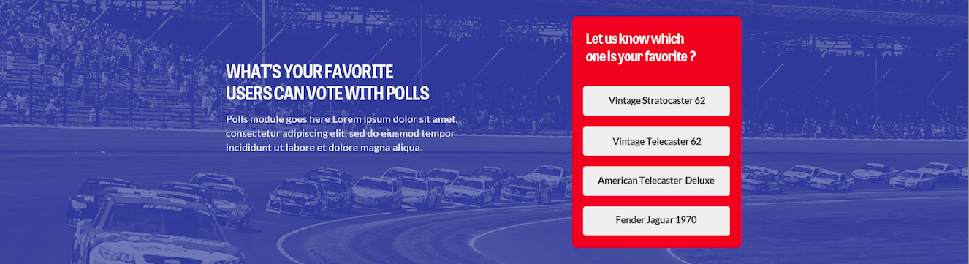

* + 1. Sponsored Ad

This is a space for brand or sponsored ad.

### A dedicated advertising/purchasing space, which contains a link to commercial opportunity of IMS.com’s choosing. The space could also be used for ads to drive conversions for IndyCar/IMS.com sponsors. Client is responsible for providing Livefyre with copy, image, URL, and any other materials to include in this space. (See Section 3 – Estimated Timelines)

### A button will be included in this space which will link out to a URL provided by Client.

### The following graphic is a mockup of the Sponsored Ad (“Mockup 8”):

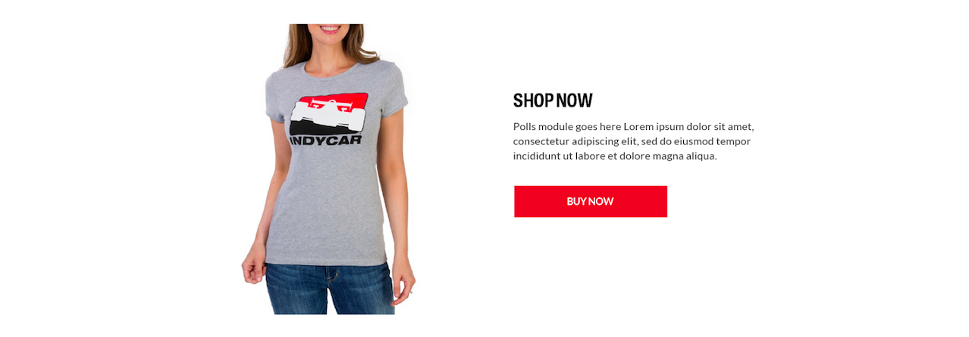

## Design

Livefyre will use Mockup 1 through Mockup 8 as the initial design for the Deliverables (the “Design Deliverables”). Client must provide any required logos, fonts or brand guidelines for IndyCar/IMS.com and its sponsors. One (1) design revisions will be allowed in accordance with the following Design Review Testing (defined in section 2.3.1):

## Design Review Testing

## Client must provide all necessary high resolution design files following execution of this SOW. Files must be received by June 9, 2015.

## Livefyre will provide Client with visual design documents (“Requested Design”) for design review.

## Client will have one (1) business day following delivery of the Requested Design to review and either “accept” or “reject” the Requested Design via written notification to Livefyre. If Client fails to provide any written notification to Livefyre within one (1) business day then the Requested Design shall be deemed accepted. If Client “rejects” the Requested Design then Client must inform Livefyre in writing of such rejection and send respond with a list of how Livefyre did not meet the Requested Design (“Design Requested Revisions”). Design Requested Revisions shall only be accepted by Livefyre if they provide a detailed description of how the Requested Design was not met in a manner sufficient to allow Livefyre to reproduce them.

## If Client provides Design Requested Revisions Livefyre will use commercially reasonable efforts to address the Design Requested Revisions.

## Livefyre will review the Design Requested Revisions, and make the appropriate design alterations. Livefyre will have one (1) business day to respond with alterations or a timeline for completion of alterations. This phase only covers Design Requested Revisions. All other revisions will be subject to the Change Control process outlined in Section 6.

## When Livefyre believes that it has made the necessary corrections, Livefyre will again deliver the Requested Design to Client and the acceptance/rejection/correction provisions in section 2.3.1.5 shall be reapplied one (1) additional time; provided, however, that upon the subsequent rejection either party may terminate this SOW by ten (10) days notice unless the Requested Design is accepted during the notice period or Livefyre may in its sole discretion agree in a signed writing to additional time to fix the failures. The termination right shall be Client’s sole and exclusive remedy and Livefyre’s sole and exclusive liability to Client. This phase will be performed a maximum of one (1) time within the scope of this SOW, provided no Design Requested Revisions shall be allowed past June 17, 2015.

## The Design Review Testing phase will end on the earlier of (i) any acceptance of the Requested Design, (ii) any termination as set forth in Section 2.3.1.6, or (iii) three (3) business days from the SOW Effective Date.

## Delivery

Outlines items/information/logos etc. from Client to Livefyre prior to production and from Livefyre to Client for the final Deliverable.

**Client Delivery**

**3.2.1** Prior to production, Client will be responsible for delivery of information outlined in Figures A-D which includes:

**3.2.1.1** Header hyperlink text and corresponding URLs (see Figure A)

**3.2.1.2** Social Account URLs (see Figure A)

**3.2.1.3** YouTube URL for embedded video (see Figure A)

**3.2.1.4** Campaign hashtag (see Figure A)

**3.2.1.5** Intro copy – next to Sponsorship logo (see Figure A)

**3.2.1.6** Copy for “Follow These Steps” (see Figure A)

**3.2.1.7 “**Top Fan Submissions” Media Wall curate rules (see Figure B)

**3.2.1.8 “**Trending Drivers” Copy (see Figure B)

**3.2.1.9** List of up to 20 drivers for the “Trending Drivers” module along with their Twitter handles (see Figure B)

**3.2.1.10** “More Fan Tweets”Media Wall curate rules (see Figure C)

**3.2.1.11** Poll Copy (see Figure D)

**3.2.1.12** Poll Question and Answers Copy (see Figure D)

**3.2.1.13** Ad Module - image, copy and button text (see Figure D)

**3.2.1.14** Footer – Copy, hyperlink text and URLs (see Figure D)

**3.2.2** Deliverables outlined in section 3.2.1 are in addition to design assets requested by Livefyre including logos, brand artwork, fonts and brand guidelines.

**3.2.3** Client will be responsible for integrating Livefyre Deliverables into the Client’s environment and making future updates outside of the requirements in this SOW. Livefyre will provide consultation to support Client endeavors during this phase.

**Livefyre Delivery**

**3.2.4** Livefyre’s professional services team will deliver code files, design assets, and documentation associated with the Design Deliverables to Client as outlined in this SOW upon acceptance of the Design Review Testing (except if during that phase the SOW is terminated).

**Figure A**

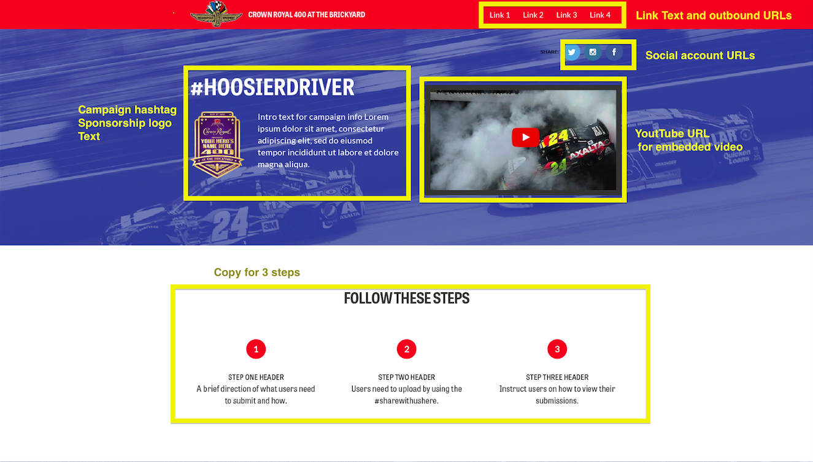

**Figure B**

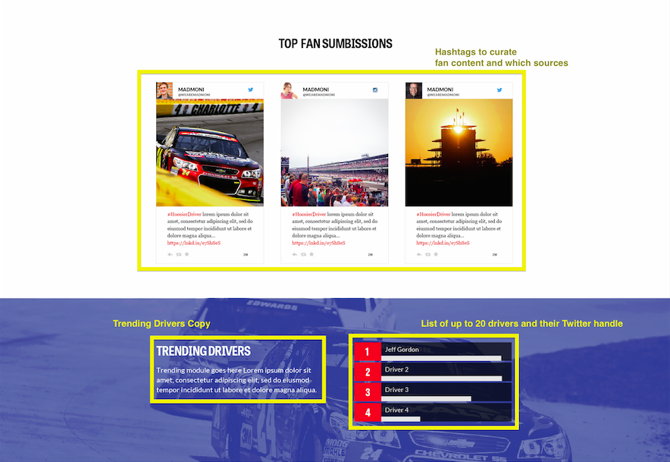

**Figure C**

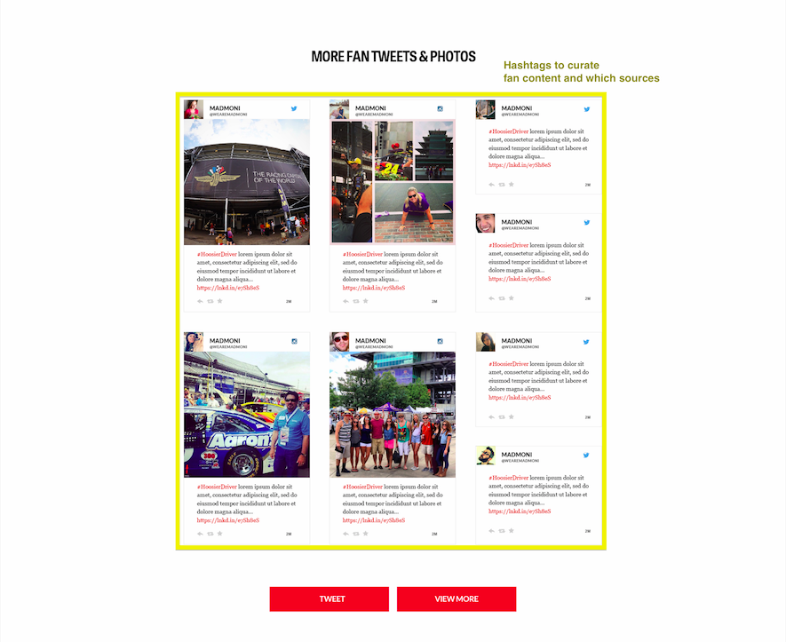

**Figure D**

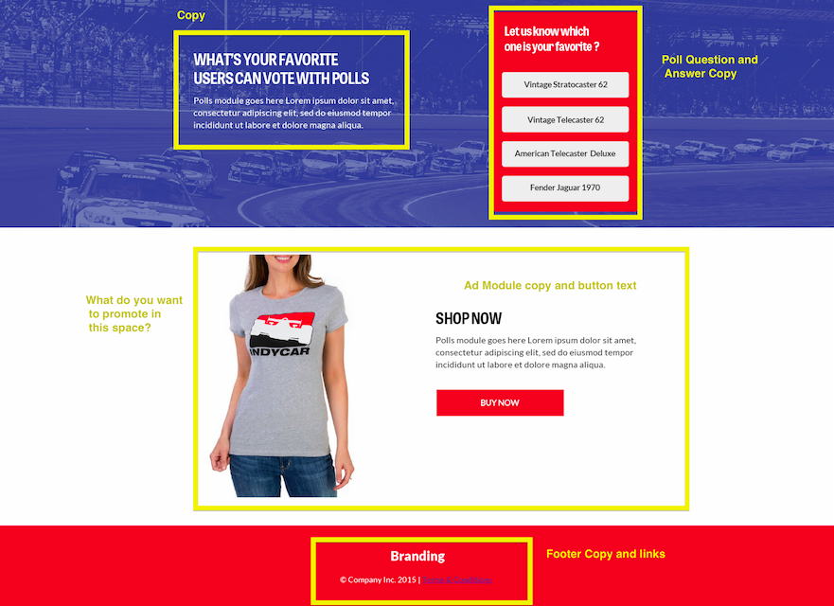

## Training

Livefyre’s professional services team will conduct one (1) remote training session during which Livefyre will demonstrate how Client can manage Polls Module and Media Wall content within the Livefyre admin panel (the “Training Session”). Training Session time and roster will be agreed to by Client and Livefyre with Client to ensure the proper stakeholders are in attendance.

This initial Training Session is limited to one (1) one (1) hour session. Additional training may be provided under a separate SOW or in the form of a Request for Change Report as outlined in Appendix A.

## Support and Maintenance (Post-Launch)

Client will have twenty four (24) hours from any acceptance of the Requested Design to notify Livefyre in writing of technical support issues specific to the Deliverable failure to meet the specifications defined within this SOW and Livefyre will provide up to five (5) hours of support only if related to a material defect of the Functional Requirements in the Design Deliverables. Except as explicitly outlined in this Section 2.6, no further support will be provided to Client.

# Estimated Timelines

These timelines are based on Client delivering creative requirements to Livefyre (as outlined in the Design Review Testing) and no material Design Request Revisions being requested. This estimated timeline is subject to change:

Implementation for Deliverables will follow the estimated timeline outlined in Figure E: Phase 1 begins following SOW acceptance date.

**Figure E**

|  |  |  |
| --- | --- | --- |
| **Deliverable Phase** | **Event** | **Deliverable Phase Duration** |
| Phase 1 | Design | One (1) week from execution of this SOW |
| Phase 2 | Development | Two (2) weeks from Phase 1 completion |
| Phase 3 | QA, Feedback and Edits | Five (5) days from Phase 2 completion. |
| Phase 4 | Delivery of final code to Client | One (1) Day from Phase 3 |

# Technical Requirements

Restrictions on browser support.

## Minimum Browser Requirements

### Desktop Browsers:

* + Internet Explorer 9+
  + Firefox (latest 2 versions)
  + Safari (latest 2 versions)
  + Google Chrome (latest 2 versions)

### Mobile:

* + Browser support for mobile is limited to the latest two versions of Safari and Chrome.

# Change Control

All project changes which could include but are not limited to new features, new functionality, alternate functionality, and unforeseen design issues, will be managed using the following change procedure:

1. Change raised by Client or Livefyre.
2. Request For Change Report (RFC) created by Livefyre.
3. RFC distributed to the Client contact.
4. If accepted change approved, change is implemented and change closure agreed.
5. If change rejected, change closed.

# Resource Requirements and Cost

## Project Cost Summary

The total fee for services associated with this SOW is $25,000, and this amount shall be invoiced on the SOW Effective Date payable twenty-five (25) days following such invoice date. Livefyre shall have the right to suspend work or development on any Deliverables or projects associated with this SOW if Client fails to pay Livefyre on time as outlined in this section 7.1(for example if Client pays Livefyre 26 days instead of 25 days, Livefyre may suspend work or development on day 25.

## Expenses

In the event that, in Client’s determination, travel is required to complete the Service defined with this SOW, Client shall be responsible for all reasonable travel expenses incurred by Livefyre associated with delivering this SOW.

## Term of SOW

This SOW shall commence on the SOW Effective Date and shall be deemed accepted upon the earlier to occur of (i) launch of the work described in this SOW, (ii) any acceptance of the Deliverables, or (ii) on **July 13, 2015**, whichever comes first.

## Client Billing Contact

BRIAN SIMPSON I Manager, Digital/Social & Photo Operations

INDIANAPOLIS MOTOR SPEEDWAY | INDYCAR/IMS.COM

4790 West 16th St | Indianapolis, IN 46222

P 317-492-5093 | C 317-979-3573

[bsimpson@brickyard.com](mailto:bsimpson@brickyard.com)

# Ownership

As between the parties, Livefyre will own all intellectual property rights with respect to any deliverables or work product resulting or arising from the performance under this SOW, as well as any derivatives, enhancements, or modifications of Livefyre’s products or services; all such rights are hereby retained by Livefyre.

# Disclaimers

* 1. All Deliverables or services not explicitly defined within this SOW are deemed excluded from this SOW.
  2. For the avoidance of doubt, costs associated with Livefyre usage based fees and ongoing support are explicitly excluded from this SOW.
  3. In the event that a third-party tool or software is used in the system (e.g. Facebook, Twitter, etc.) and that third-party alters its functionality or operation, Livefyre cannot guarantee that the functionality delivered as part of this SOW will continue to function as designed. Furthermore, in the event that additional work is required due to changes made by the third-party, the cost of this additional work will be passed along to the client in the form of a Request for Change Report (Appendix A).
  4. Client is solely responsible for use of the Deliverables. Client’s use of the Deliverables shall be in compliance with all applicable laws and regulations.

# Authority to Proceed

IN WITNESS WHEREOF, this Statement of Work is executed on behalf of each party by its duly authorized representative and agreed to and accepted by:

**IndyCar/IMS.com**

Signature: ______________________________________________________

Name:

Title:

Date:

**Livefyre**

Signature: ______________________________________________________

Name:

Title:

Date:

# Appendix A

## Request for Change

A Request For Change (RFC) for this SOW must contain the following information:

1. Description of Change:
2. Reason for Change:
3. Timeframe to Implement:
4. Projected Cost Summary:

|  |  |  |  |
| --- | --- | --- | --- |
| **Resource Type** | **# of Hours** | **Hourly Rate** | Total |
| Strategy | NA | $199 |  |
| Design | NA | $199 |  |
| Development | NA | $199 |  |
| Project Management | NA | $199 |  |
| Quality Assurance | NA | $199 |  |
| **Total** |  | NA |  |

Additional work beyond the estimates outlined in this Appendix will be performed at Livefyre’s current standard hourly rates, to be determined and outlined in an appropriate Request for Change Report, contained in Section 10.1 of this document.

These terms regarding additional work, must be agreed to and approved by both Livefyre and Client before proceeding.